HVM REQUEST CHECKLIST
- Photos - Please include a minimum of three or more pictures of the space where the modification will take place. This helps us see the condition of the home, the size of the space, and allows us to better understand the existing situation and better assist the member.
- Example: If submitting a request for a walk-in shower, please send photos of the existing bathroom space, existing tub/shower unit, and any other details that you think would be helpful.
- Basic measurements – Please do your best to assess the size of the existing space. While this is not a requirement, we highly suggest gathering some basic measurements so that we can better help you and the member.
- Example: If submitting a request for a wheelchair ramp, please take a rough measurement from the door threshold to the ground. Ask the member where they would like for the ramp to end up, and measure how far away the distance is.
See illustration below:
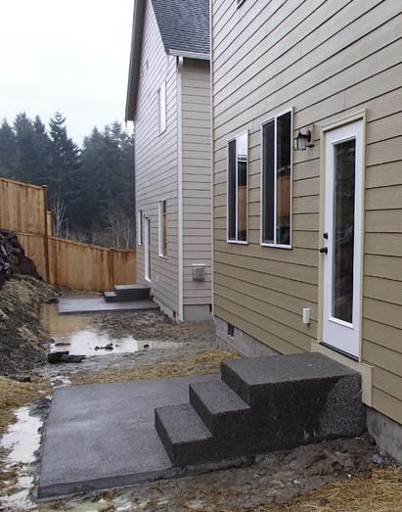
Ramp will end here
If submitting a request for a walk-in shower, please take measurements of the bathroom space (LENGTH and WIDTH of the room and LENGTH and WIDTH of the existing tub or shower unit). You may include these measurements in the photos or submit them in the notes section of the HVM form.

- Member details – Be sure to give us all the information needed to reach out to the member. This would include the waiver type, the member’s name, address, and phone number. Please include details such as the parent/guardian information, best point of contact and any other information you feel is necessary.

